Project 8-3: MAC Spoofing
Estimated Time: 20 minutes
Objective: Demonstrate a MAC spoofing attack.
Description: In a MAC cloning attack, a threat actor discovers a valid MAC address of a device connected to a switch. They then spoof that MAC address on their device and send a packet onto the network. In this activity, you spoof a MAC address.
- Go to the Technitium website at technitium.com/tmac/. (If you are no longer able to access the program through this URL, use a search engine to search for “Technitium MAC address changer.”)
- Click Download Now.
- Click Direct Download.
- Save the file to your computer and then install the application.
- Launch the application.
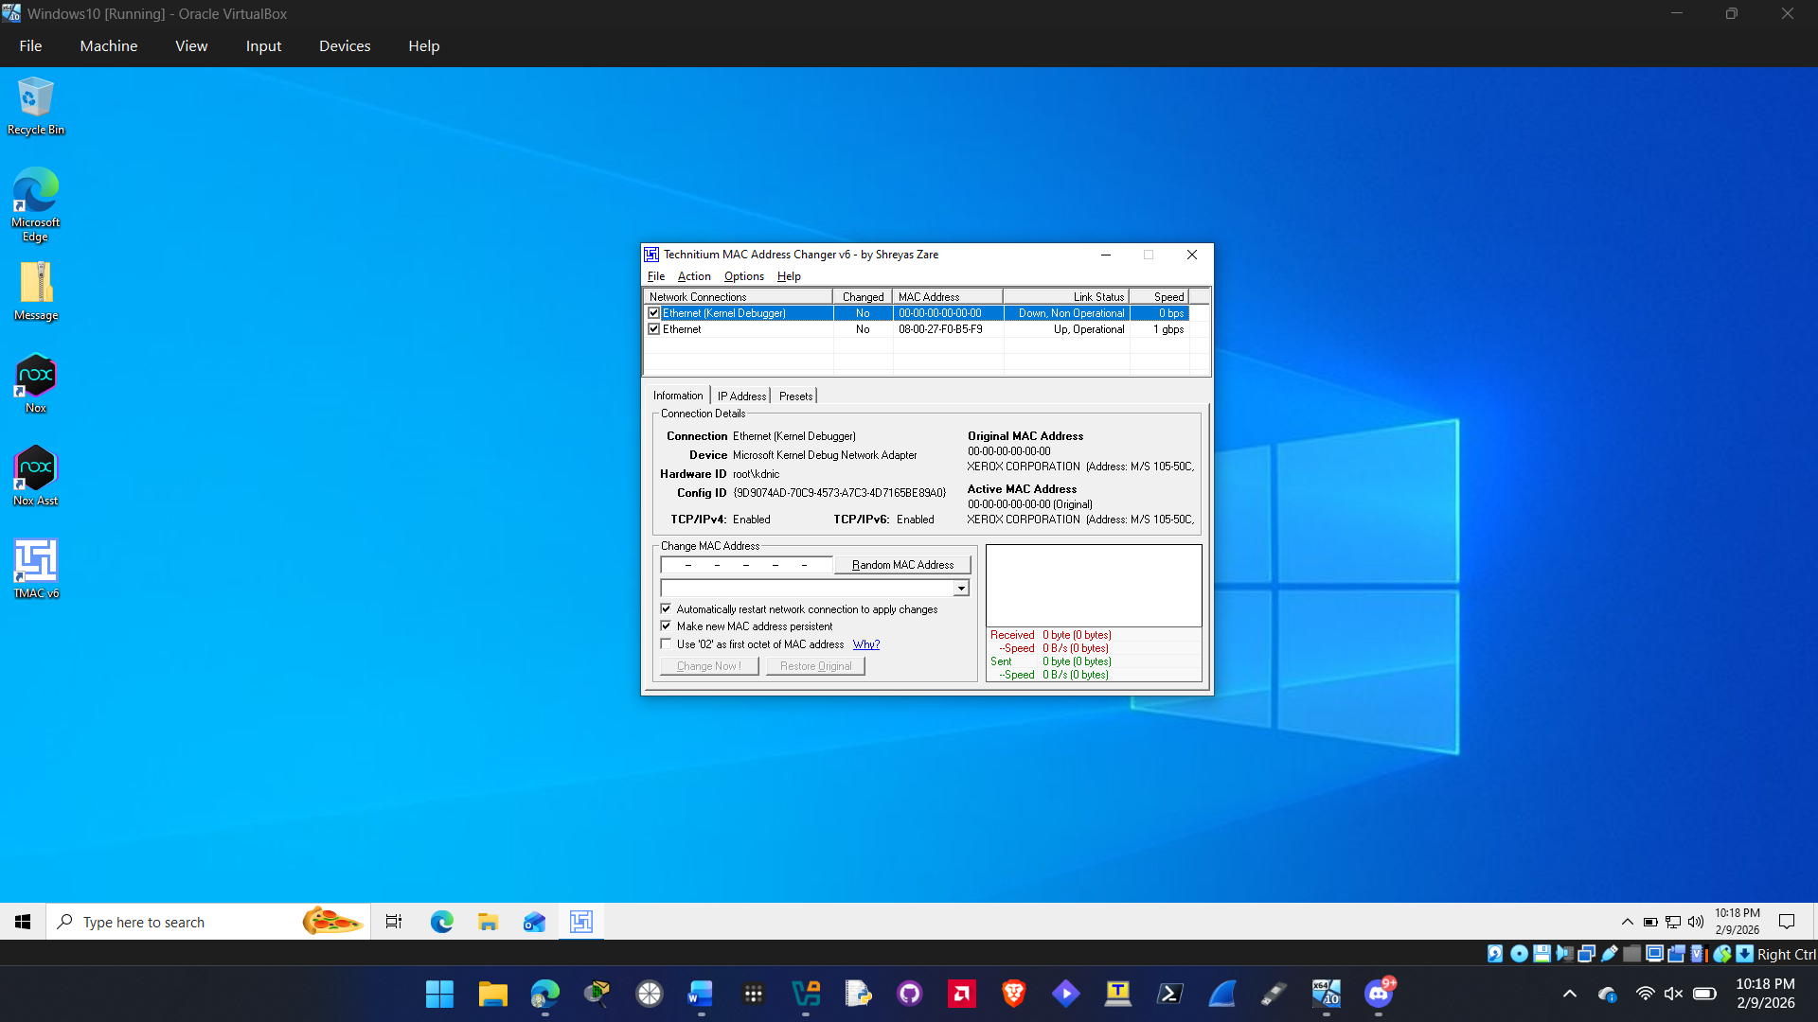
- If necessary, click Yes to respond to the pop-up dialog box.
- Scroll through the list of network connections on your computer.
- Select the network connection that is your Internet connection.
- Read the information on the Information tab.
- Click Random MAC Address to display another MAC address that can be assigned to this device.
- Click the down arrow in the box below the new random MAC address. Note the long list of different NIC vendors from which a MAC address can be chosen.
- Click (2C-30-33) Netgear.
- Look at the new MAC address under Change MAC Address and note the first three pairs of numbers. What does this correspond to?
The first 3 pairs of numbers in a MAC address correspond to the manufacturer of the network adapter. This is also called an OUI of the MAC address where it identifies the vendor.

- Click Why? next to Use ‘02’ as first octet of MAC address.
- Read the explanation about why 02 should be used as the first octet.
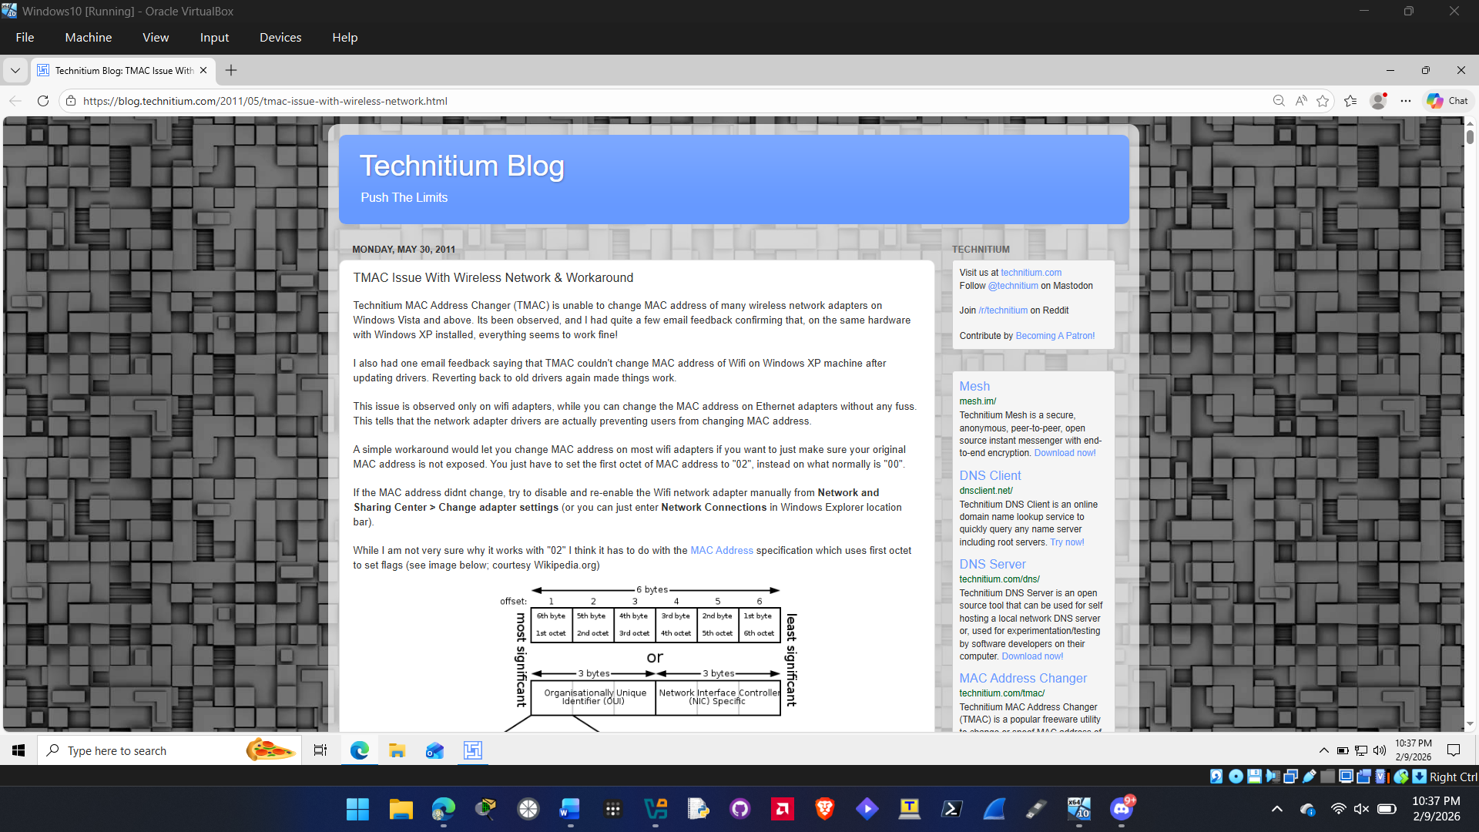
- If you want to change your MAC address, click Change Now! or close the application if you do not want to change the address.
- How easy was it to spoof a MAC address? How can a threat actor use this in a MAC cloning attack?
It was very easy to spoof a MAC address. After downloading the software, you can click just two buttons to spoof your MAC address. Threat actors can use this by bypassing Access control requirements like MAC filtering to gain unauthorized access to a network. They can also spoof other devices to make it look like a trusted device on the network. Threat actors can also use this for man in the mooddle attacks and public Wi-Fi hijacking.

- Close all windows.

Criteria | Meets Requirements | Needs Improvement | Incomplete
Content | The assignment clearly and comprehensively addresses all questions in the assignment.  15 points | The assignment partially addresses some or all questions in the assignment.  8 points | The assignment does not address the questions in the assignment.  0 points
Organization and Clarity | The assignment presents ideas in a clear manner and with strong organizational structure. The assignment includes appropriate content, coverage of facts, arguments, and conclusions.  10 points | The assignment presents ideas in a mostly clear manner and with some organizational structure. The assignment includes appropriate content, coverage of facts, arguments, and conclusions.  7 points | The assignment does not present ideas in a clear manner or with a strong organizational structure. The assignment includes some appropriate content, but coverage of facts, arguments, and conclusions are not logically related and consistent.  0 points
Research | The assignment is based upon appropriate and adequate data collection and analysis of results from the activity or research from academically reliable sources.  5 points | The assignment is based upon adequate data collection and includes some analysis of results from the activity or research from academically reliable sources.  3 points | The assignment is not based upon appropriate data collection and includes no analysis of results from the activity or research from academically reliable sources.  0 points
Grammar and Spelling | The assignment has two or fewer grammatical and spelling errors.  5 points | The assignment has three to five grammatical and spelling errors.  3 points | The assignment has more than five grammatical and spelling errors, is incomplete, or is unintelligible.  0 points

